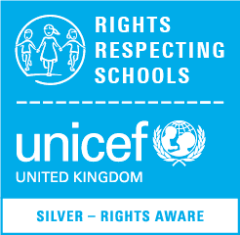

Tel: 0191 487 6703 www.harlowgreen.org
Autumn 2 2022

Introduction

Hello everyone! We are the Rights Respecting School Officers for Harlow green and we would like to welcome you to the very first newsletter from our steering group. We meet each week to discuss how we can make our school the best it can be.
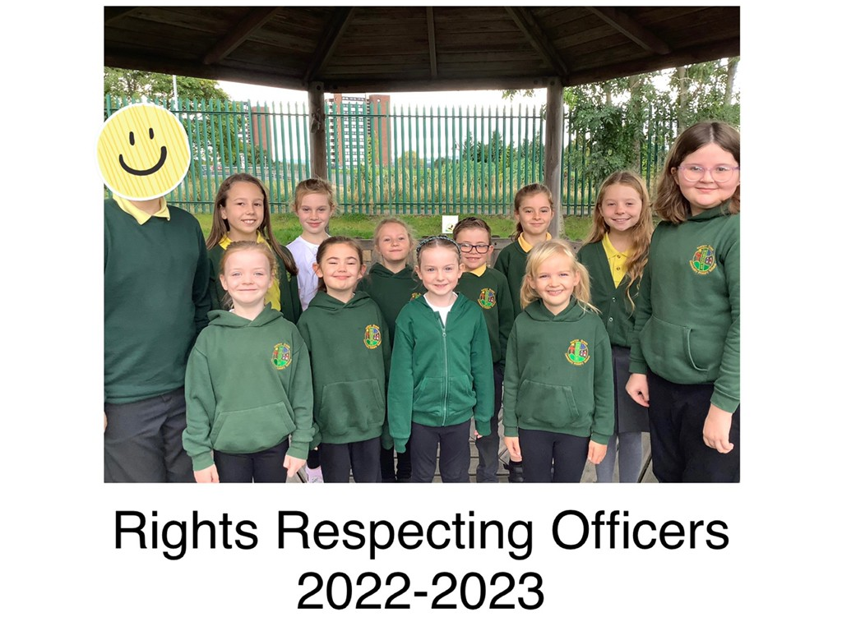

I am Connie and I am looking forward to teaching people how to be kind and caring to other children. I loved helping with Children in Need.

Hello my name is Annabel and I am looking forward to having a voice as part of our school during the meetings.

I am Dakota and I wanted to be a Rights Officer to help people and make sure everyone is nice to each other.

Hi, I am Eva. I am excited to help all our parents and carers learn about the meaning of rights.

My name is Aidan and I have enjoyed being part of our Anti-Bullying week. It is so important for us to learn about why we need to be kind to each other.

I am Daisy and I can’t wait to be involved in more fundraising events across the year.

Hello I am Wilf and I am looking forward to being a Rights Respecting Officer to help and listen to anyone if I can.

I am Cara and I am excited to be part of a community that helps other children and adults learn about their rights and give them access.

Hello my name is Carys and I thought it would be fun to help our school community and plan events.

Hi I am Hollie and I want to make sure all children have access to their rights in Harlow Green.

Hi I am Robyn and I want to be a Rights Officer to help others if they have yucky feelings.

I am Georgie and I wanted to be a Rights Officer to help everyone who might need to le listened to.

Article 12: We all have the right to say what we think. Adults should listen and take us seriously.

Our UNICEF FAQ

What is UNICEF’s Rights Respecting Schools Award?
This recognises achievements in putting the United Nations Convention on the Rights of the Child (UNCRC) at the heart of a school’s planning, policies, practices, and ethos.

What is the UNCRC?
This sets out the human rights of all children under the age of 18 and is the most widely adopted international human rights treaty in history.

Why is Harlow Green a Rights Respecting School?
Harlow Green is a school that aims for everyone to grow happy, healthy, and successful together. We are currently a Silver Awarded Rights Respecting School. This means we are a rights aware school working on our journey towards Gold.

How does Harlow Green ensure Children’s Rights are achieved by all?
- Every class has an agreed Class Charter.
- Children learn about Rights across all areas of the curriculum.
- We have special class assemblies each week linked to our Rights.
- We actively campaign to make a difference in our school, community and across the world. We support many charities and campaigns including: Children in Need, Comic/Sport Relief, Walk to School Week, Road Safety, UNICEF Outright Campaign for World Children’s Day, Anti-Bullying Week, and many other events across the school year.

Article 3: Everyone who works with children should always do what is best for the child.

Tips for Parents/Carers
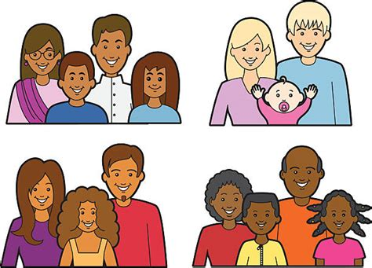
- Adults are known as Duty Bearers and children as Rights Holders.
- Adults have a responsibility to ensure that all children have access to their rights (Universal).
- (Inalienable) and children do not have to do anything to earn their rights (Unconditinal) as they are there from birth (Inherent).
- The UNCRC supports parents/carers to make informed decisions tat promote children’s best interests.
- Adults are encouraged to discuss decisions made by world leaders and national charities and campaigns.

For more information visit:
UNICEF https://www.unicef.org/child-rights-convention
RRSA https://www.unicef.org.uk/rights-respecting-schools/

Article 17: We all have the right to be given safe and honest information, which is not harmful, and that we can understand.

Feeding Families
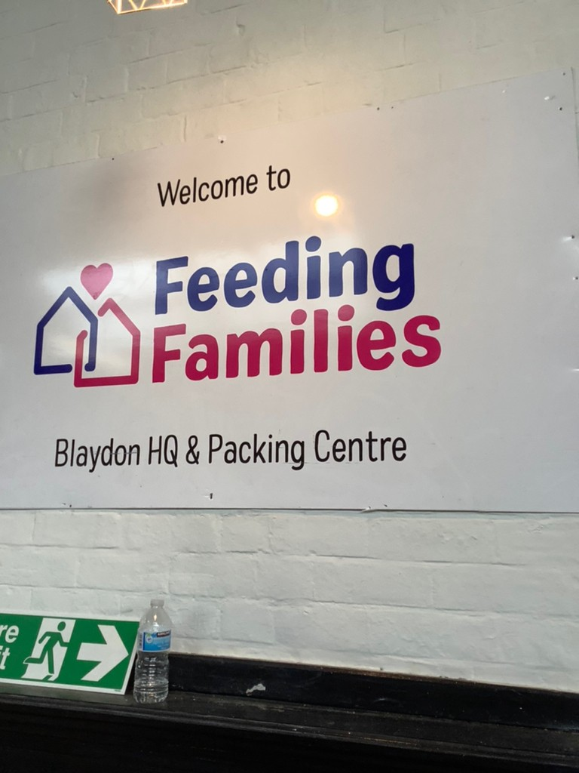
In October, we collected so much food for our Harvest Festival and donated it all to Feeding Families in Blaydon. They were so impressed by all the donations we had collected and invited us to visit their HQ.

All the Officers were lucky enough to go and visit on Thursday 10th November and help support Ian, one of the volunteers, to pack up emergency parcels for the local community. We managed to pack a huge 59 emergency food parcels which had a variety of foods included such as cereal, milk, tea/coffee, tinned foods, pasta/rice, sauces, and biscuits.

If you missed our website post with photos have a look to find out what we found out while on our visit.

Article 24: We all have the right to healthy food and clean water to drink.

Children in Need
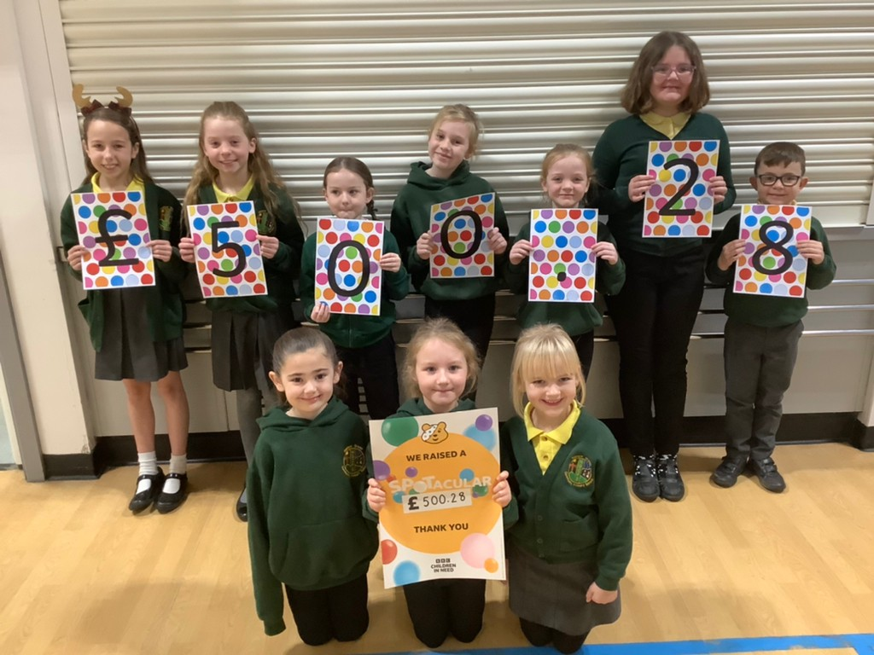
Children in need took place on Friday 18th November and we spent the day covered in Pudsey clothing and accessories as well as millions of spots. We learnt about the meaning of Children in Need and why it was originally set up. We wanted a way of making even more money this year, so we came up with a spotty sweet guessing competition. This involved counting out a huge number of sweets into three tubs for the three lucky winners across school.

We are so proud of our school community and the amount of money we managed to raise – THANK YOU!

Article 19: We all have the right to be protected and kept safe.

Upcoming Events
December
Feeding Families collection Friday 2nd December
Christmas Jumper Day Wednesday 7th December
Christmas Productions W/C Monday 12th December
January
Big Schools Birdwatch Friday 6th January – Monday
20th February
February
Safer Internet Day Tuesday 7th February
March
World Book Day Thursday 2nd March
Comic Relief Friday 18th March
World Water Day Tuesday 22nd March

Anti-Bullying Week
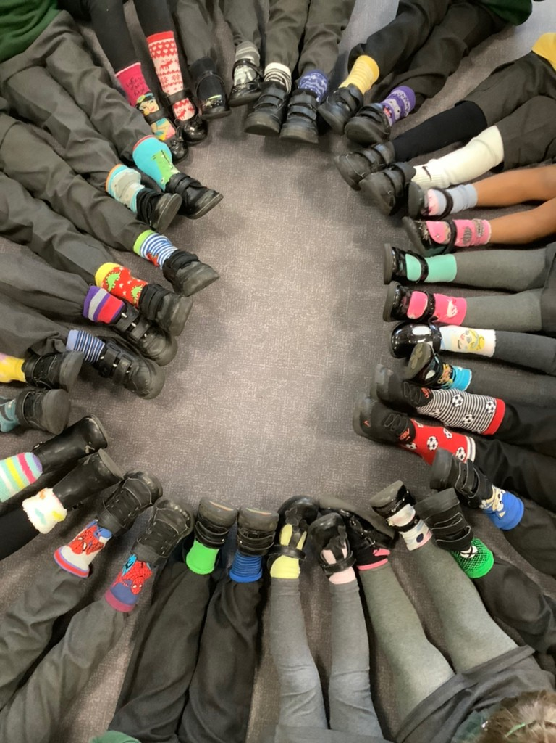
This year, as part of Anti-Bullying Week, we took part in the annual Odd Socks Day to unite against bullying! There were many fancy and different socks across school, all showing that everyone is unique. We learnt this year about the theme ‘Reach Out’. This taught us all of the importance to reach out and to talk to someone we trust if we are feeling upset, scared or worried about bullying.

Article 15: We all have the right to friends.

Christmas Collections
We managed to collect many donations towards our Christmas Hamper Appeal linked with Feeding Families. The donations will go towards making many food hampers for those who are struggling with the rising cost of living this Christmas. Below is a list of suggested items if anyone would like to further donate and drop them off at Blaydon HQ.
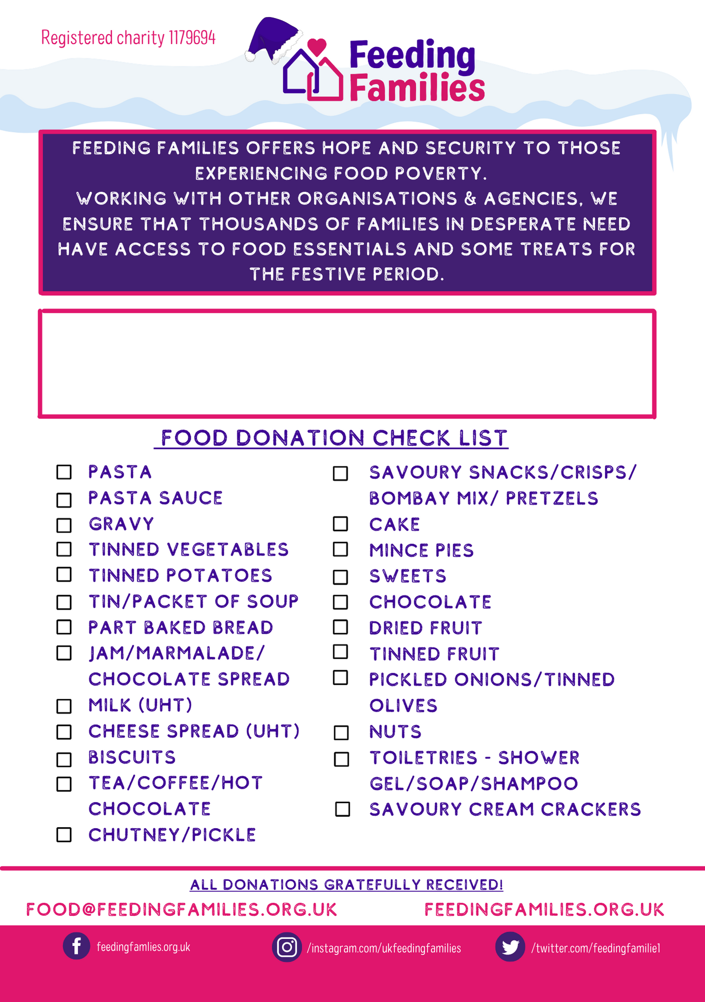

Maybe you would be interested in becoming a volunteer to help support making up the Christmas hampers to give back to the local community this year. Feeding Families, are always in need of volunteers so do check their website and Social Media platforms to get involved.
https://feedingfamilies.org.uk/volunteering/

Article 6: We have the right to be alive, survive and develop in the best possible way.

Cost of Living Crisis

Over the next term, we will be working on how we can save money and make sure nothing is going to waste in order to make the most during the current cost of living crisis. In school, we will be focusing on;
- Turning off the lights when we leave the classroom for lengthy periods of time.
- Not leaving the taps turned on when we have finished washing our hands.
- Recycling paper and waste batteries (especially after Christmas).

Article 27: We all have the right to a good standard of living.

