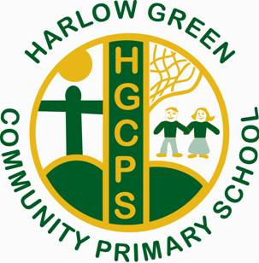
Harlow Green Community Primary School
Minutes from PTA Meeting
Wednesday 6th April at 2:30pm
Thank you to those who attended with Ms Rowe & Mrs Taylor.
The following items were discussed:
Welcome and Introductions
- Everyone present introduced themselves and any experience they have of events.
- Miss Rowe & Mrs Taylor explained the school are really excited to welcome the community back into school after the pandemic.
Name of the PTA
To relaunch the new PTA, it was discussed we would like a new name instead of “Harlow Green Unite” Ideas would be discussed next meeting.
Events
Discussed due to the 2 year pandemic, children have missed out on many social events.
Events discussed were Halloween & Valentine Disco, Summer & Winter Fair amongst others.

PTA members were all given a tour of the Forest School area by Ms Rowe.

More PTA volunteers …
And finally, the PTA would welcome more parents and grandparents to support and raise money for school. Another meeting will be organised in May.

