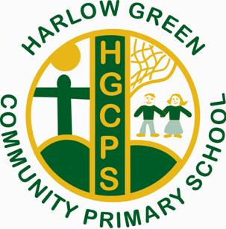
Harlow Green Community Primary School
Minutes from PTA Meeting
Thursday 8th November at 2:30pm
Thank you to those who attended with Mrs Chapman.
The following items were discussed:
Children In Need Coffee Afternoon
- PTA will ask for more volunteers to hold this event
- A text from school will be sent to ask for donations of cakes and biscuits
- Nearly new uniform will be sold at the event
Local Charities
In addition to supporting nationwide charities, our PTA will raise money for one local charity. Our School Council are currently busy choosing a charity.
Christmas Events
PTA will help out to sell raffle tickets and refreshments at all of our Christmas shows.
More PTA volunteers …
And finally, the PTA would welcome more parents and grandparents to support and raise money for school. Another meeting will be organised in January.

